Problem 1 [25 pts]: Using PVA analysis
Consider the mechanism drawn below. The goal is to algebraically determine the velocity, position, and acceleration at point C using PVA analysis. Assume the following:
$O_{2}= (0,0)$, $O_{4} = (27.5,0)$,
$A=(7.5,10)$, $B=(19.5,15)$, $C=(3.5,14)$,
$ω_{4}=1 rad/s$, $α_{4}= -2rad/s^{2}$

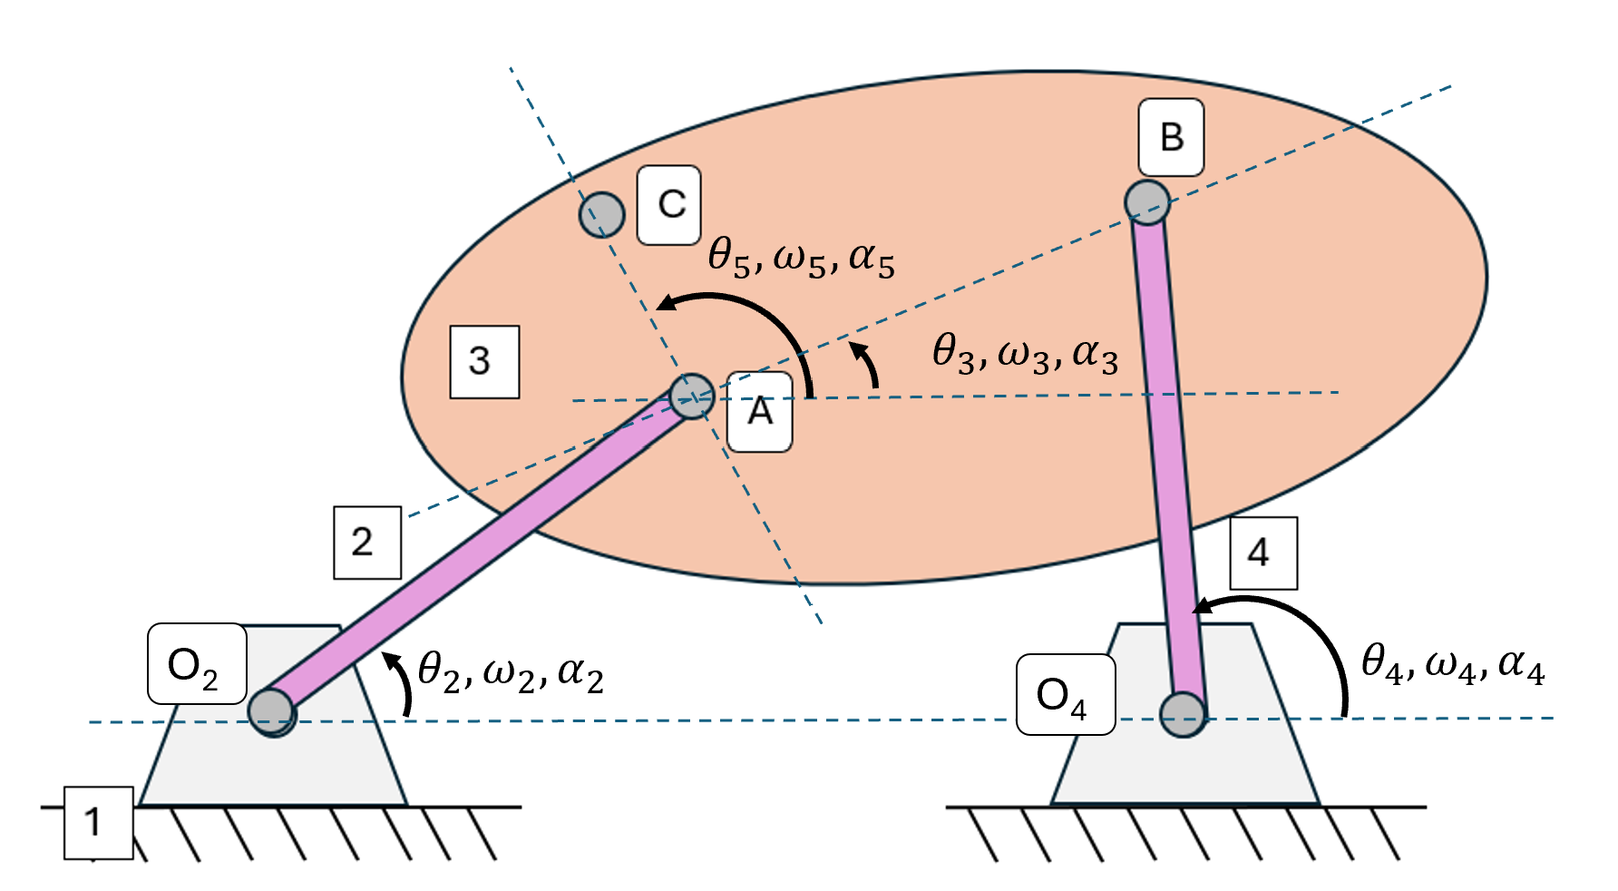
Hint: This problem may look like one you completed when we studied instant centers, which could be useful for performing a sanity check on your answers
- Write out the vector loop equations for the position, velocity, and acceleration of C
- Compute the lengths of O₂A, O₂O₄, AB, BO₄, and AC
- Compute the angles ϑ₂, ϑ₃, ϑ₄, ϑ₅
- Compute the angular velocities ω ₂, ω ₃, ω ₄, ω ₅
- Compute the angular accelerations α ₂, α ₃, α ₄, α ₅
- State the linear velocity and acceleration of point C

Show all work for full points

Select one of the following options:
- My answer was created by a Gen AI algorithm, and I have not modified it
- My answer was created by a Gen AI algorithm, and I have made some minor changes.
- My answer was created by a Gen AI algorithm, and I have made major changes.
- My answer was created solely by myself.
- If I used Gen AI, I used ___ (name of program).

